End-to-End MLOps Pipeline for Heart Disease Prediction
Course: MLOps (S1-25_AIMLCZG523)
Assignment: Experimental Learning Assignment – I
Program: M.Tech (AI & ML)
University: BITS Pilani (WILP)
Student Name: ____________________
Roll No: ____________________
Semester: Spring 2025

Table of Contents

- Abstract
- Dataset Description
- Setup/install instructions
- Exploratory Data Analysis
- Experiment Tracking
- CI/CD Pipeline
- Containerization & Deployment
- Monitoring & Logging
- Limitations & Future Work
- Conclusion
- References

Abstract
This report presents a complete end-to-end MLOps pipeline for heart disease prediction. The solution demonstrates data preprocessing, model training, experiment tracking, CI/CD automation, containerization, Kubernetes deployment, and monitoring.
MLOps extends DevOps principles to machine learning systems to ensure scalability, reproducibility, and reliability in production. This project showcases a production-grade ML system aligned with industry best practices.

Dataset Description
The Heart Disease UCI dataset contains 14 clinical attributes such as age, cholesterol, blood pressure, ECG results, and a binary target variable.

Setup/install instructions.
Prerequisites
Python 3.10+
Docker
Git
Kubernetes (Minikube / Docker Desktop)
MLflow

Setup
```bash
git clone <GITHUB_REPOSITORY_URL>
cd heart-disease-mlops
python -m venv venv
source venv/bin/activate # Linux/Mac
pip install -r requirements.txt
python src/train.py
mlflow ui

Exploratory Data Analysis
EDA was conducted using histograms, correlation heatmaps, and class distribution plots to understand data characteristics and guide preprocessing decisions.
Below are the observations at the end of EDA
- Target class is moderately balanced
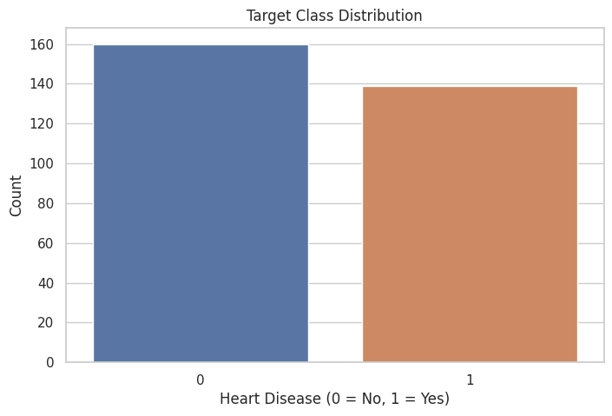
- Features distribution analysis like age, cholesterol
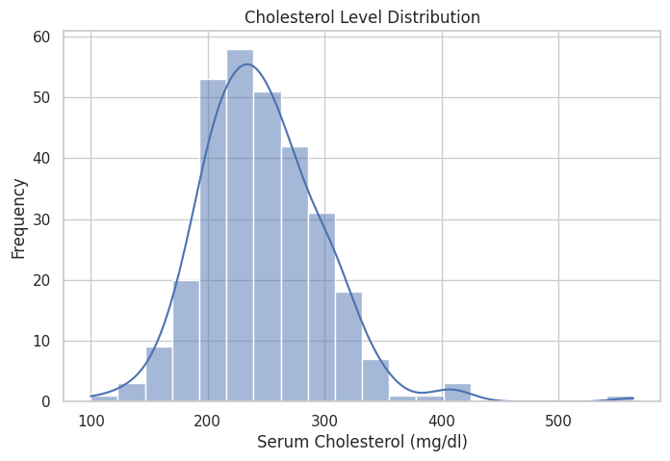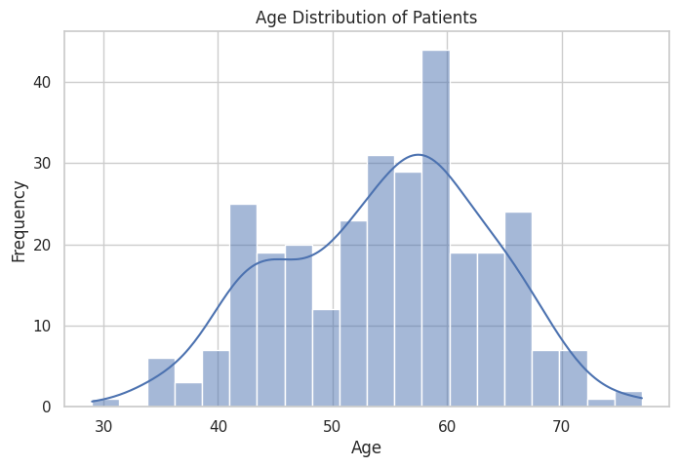
- Correlation heatmap - Features such as age, maximum heart rate, and exercise-induced angina show strong correlation with heart disease
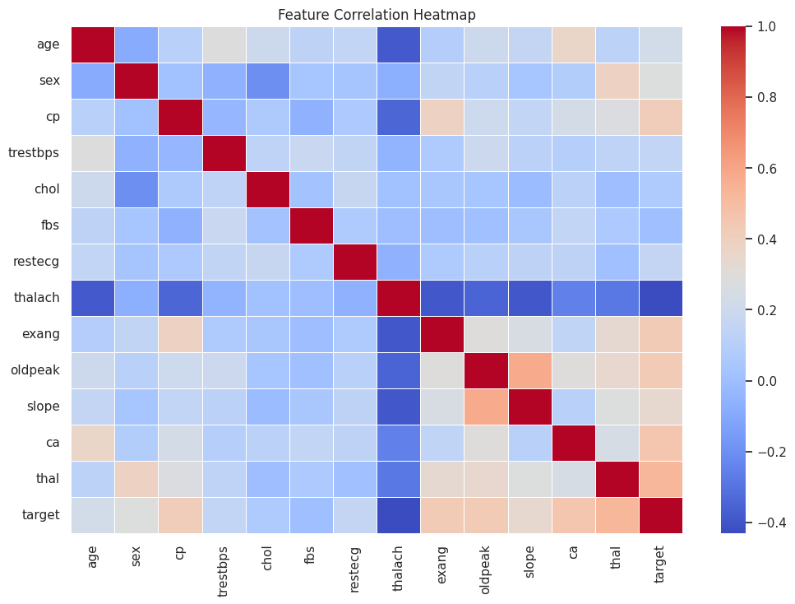
- Feature vs Target (key clinical insights)
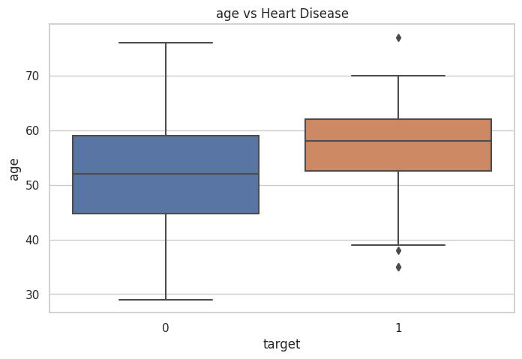
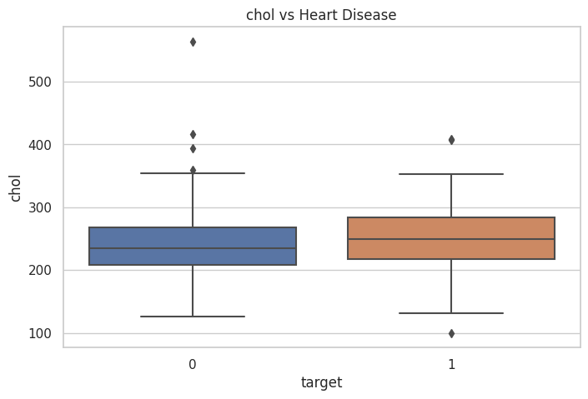
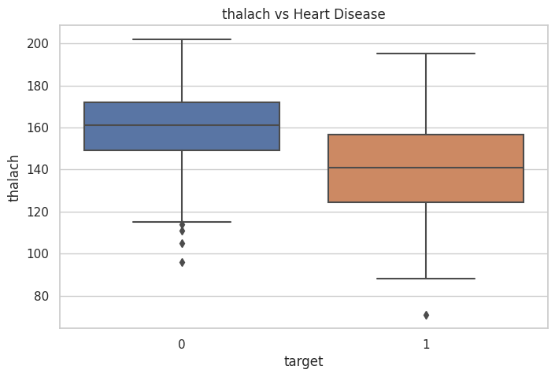
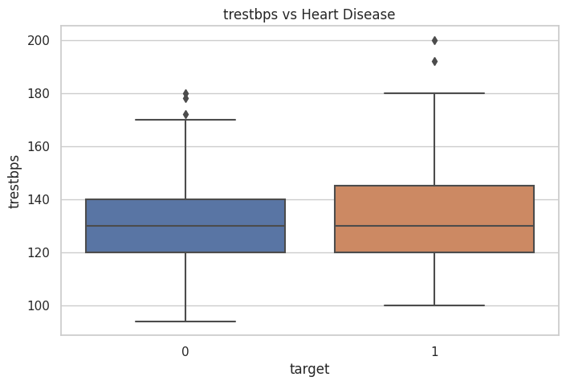

8. Experiment Tracking.

MLflow was used to track:
- Model parameters
- Metrics
- Artifacts
- Model versions

Benefits
- Full reproducibility
- Easy comparison of experiments
- Model registry for production promotion

Experimental runs reflecting in the experiment tab of “Databricks MLFlow”

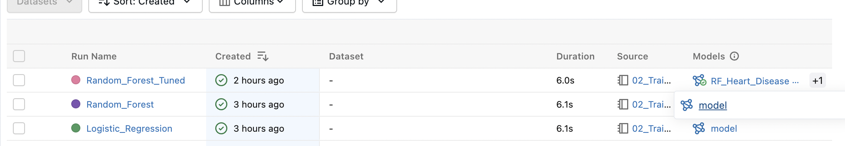

Experiment tracking UI showing metric for a specific Logistic run
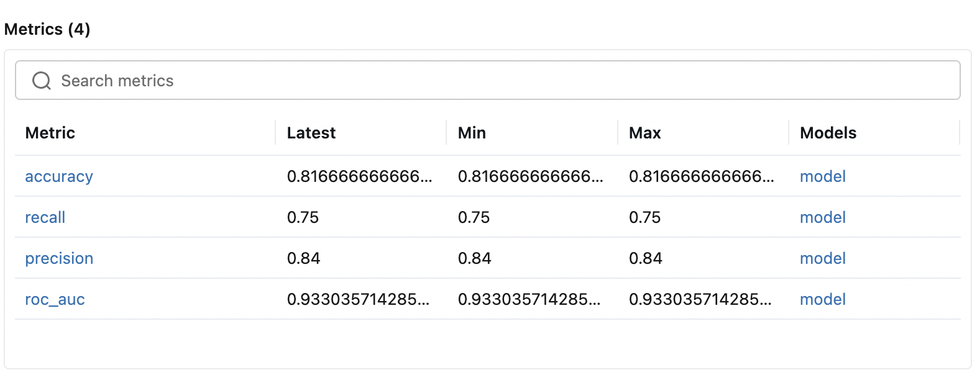
Experiment tracking helps in comparing parameter and metric visually for different model

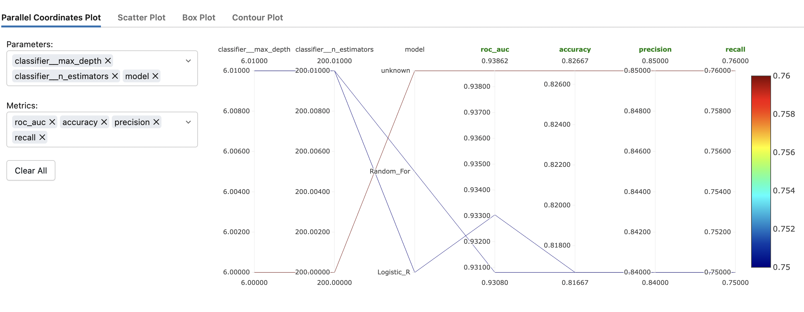

5. System Architecture (End-to-End MLOps Flow)
Figure below illustrates the end-to-end MLOps architecture used in this project, from data ingestion to production monitoring.
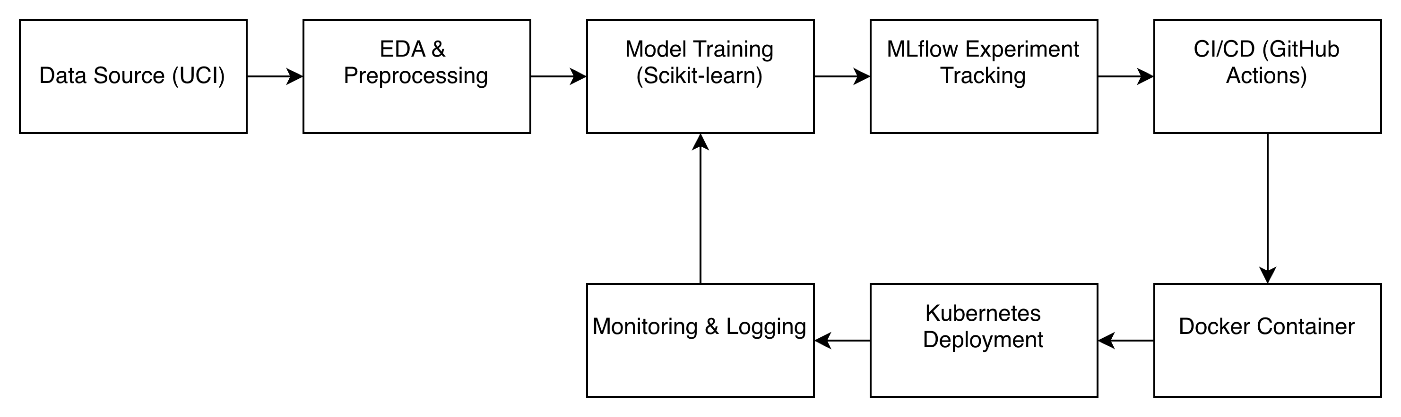

9. CI/CD and deployment workflow screenshots
GitHub Actions workflow
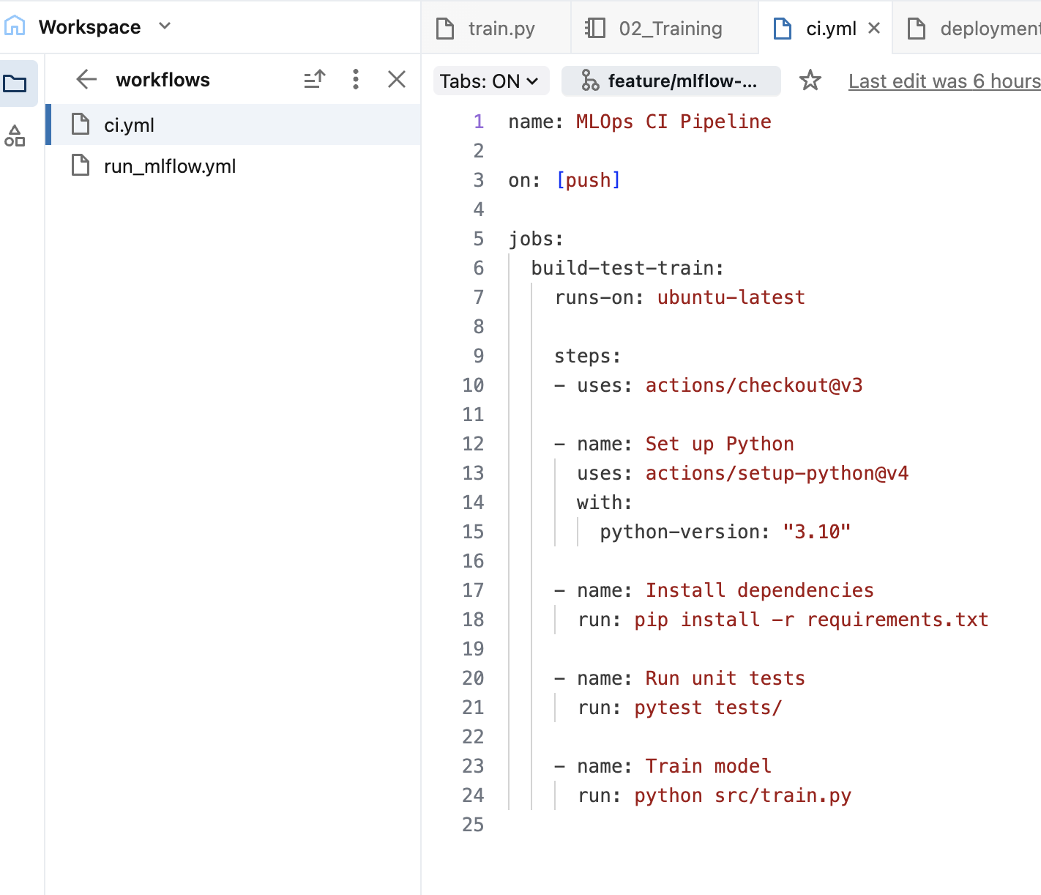

Deployment workflow
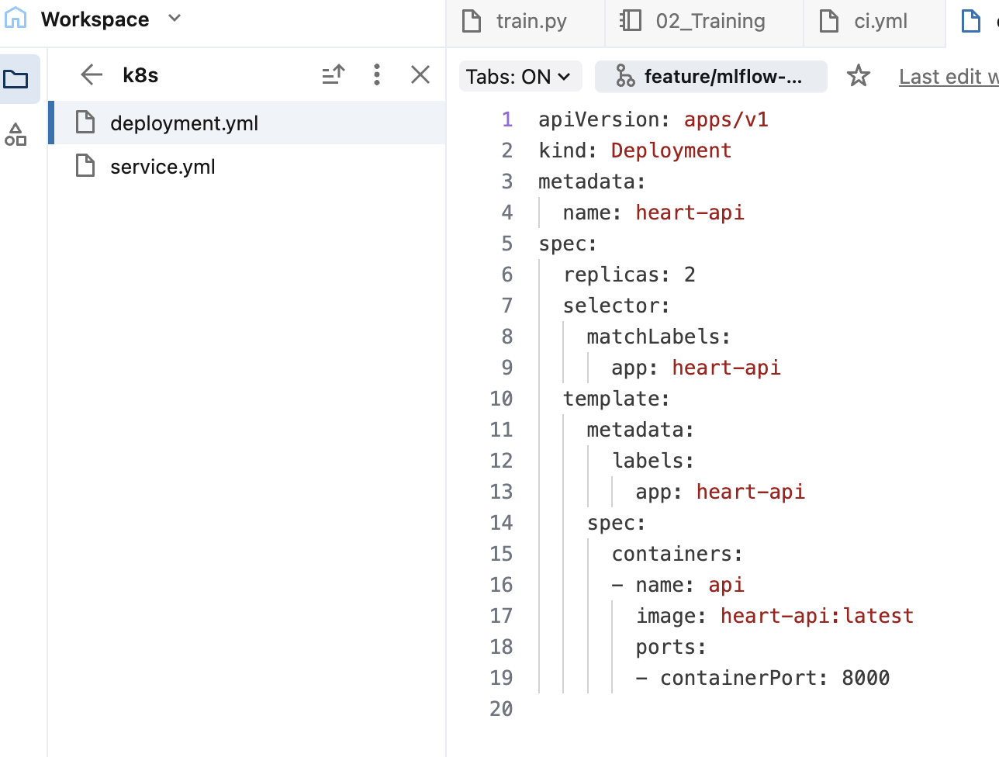

10. Link to code repository

https://github.com/rakeshjha4385/Group_125_MLops_Assignment_1/tree/main

Containerization & Deployment
The trained model was deployed as a FastAPI service and containerized using Docker. Kubernetes was used for scalable deployment.

11. Monitoring & Logging
Application logs capture inference requests and responses. The design supports Prometheus and Grafana integration.

12. Limitations & Future Work
Future improvements include automated retraining, data drift detection, model performance alerts, and feature store integration.

13. Conclusion
This project demonstrates a full MLOps lifecycle and highlights the importance of automation, scalability, and monitoring in ML systems.

14. References
1. UCI Machine Learning Repository
2. MLflow Documentation
3. Kubernetes Documentation
4. Scikit-learn User Guide

